1. 

**Employee performance**

**Analysis**

Student name : P.kalaivani

Register no : 312213077

Department : B.com(Commerce)

Colleg: Vel tech ranga sanku arts college, Avadi

# EMPLOYEE PERFORMANCE ANALYSIS

**AGENDA**

Problem statement Project overview End users

Our solution and proposition Dataset description Modelling approach

Results and discussion Conclusion.



**Problem statement**

* Job knowledge and technical skill
* Communication and team work.
  + Problem solving and adaptability.
* Time management and productivity .



# PROJECT OVERVIEW

Develop an excel workbook with user- Friendly data entry and update funtionality.

Create automated calculations for performance scores and ratings.

Design conditional formatting to highlight strengths and weaknesses.



# END USERS

* Streamlining performance analysis and feedback processes
* Enhancingdata-driven decision-making.
* Improving talent development and growth initiatives.
* Increasing effiency in performance review processes.
* Better identifying top performers and areas for performance.



# OUR SOLUTION AND PROPOSITION

1. User friendly data entry : easy to use interface for inputting employee performance data
2. Automated calculation : Performance scores and ratings calculated instantly.
3. Enhance performance management : through streamlined process and automted calculations.
4. Gained or competitive advantage : by developing a high performing work force.



DATASET DESCRIPTION

Employee Information Performance Metrics Performance Ratings

Feedback and Comments* Goals and objectives Feedback and comments table

Historical performance data



# MODELLING APPROACH

Descriptive Analytics:

Use Excel formulas and functions to calculate

performance metrics and ratings.

Inferential Analytics:

Analyze the impact of individual metrics on overall performance ratings.

Predictive Analytics:

Identify key drivers of performance and areas for improvement.

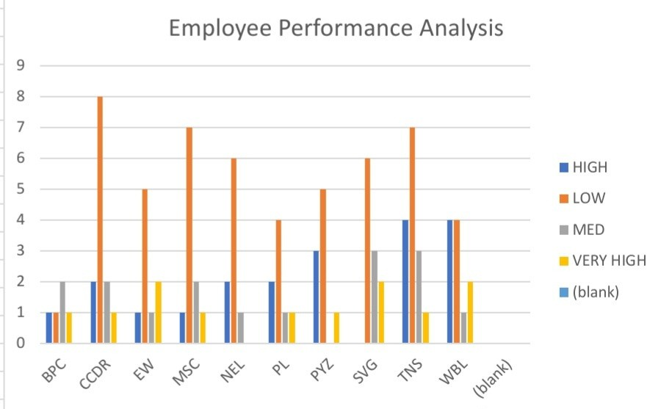

# RESULTS AND DISCUSSION



**CONCLUSION**

In conclusion, the employee performance evaluation. process can be enhanced through the use of

data analytics. By leveraging descriptive, inferential, predictive, and

prescriptive analytics,organizations can:

* 1. Gain a deeper understanding of employee performance
  2. Identify areas for improvement
  3. Develop targeted talent development programs
  4. Inform performance improvement initiatives
  5. Drive business outcomes

# THANK YOU.....